# **Salesforce Admin Lightening Experience**

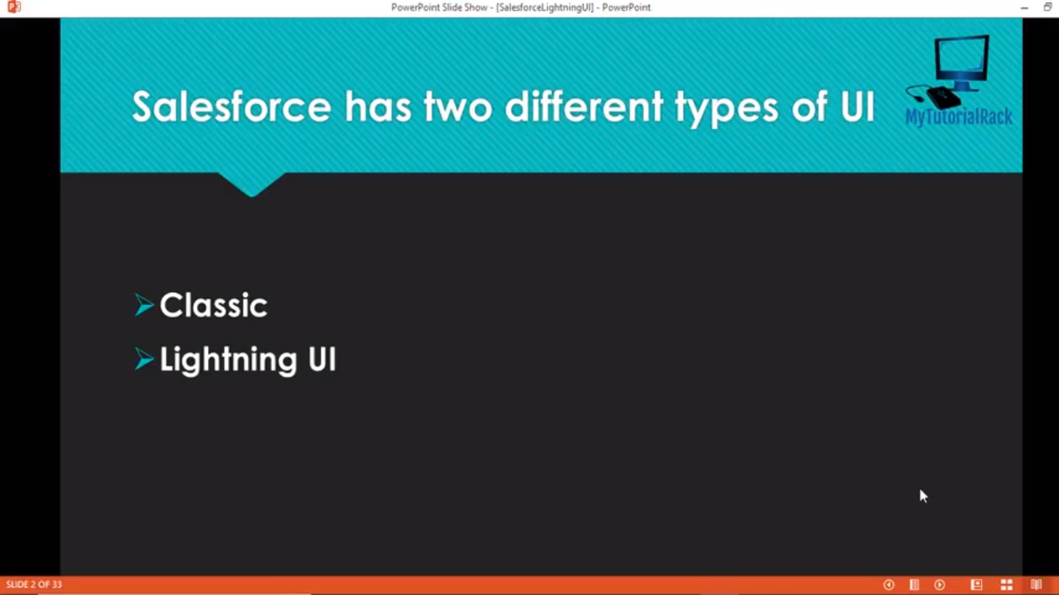

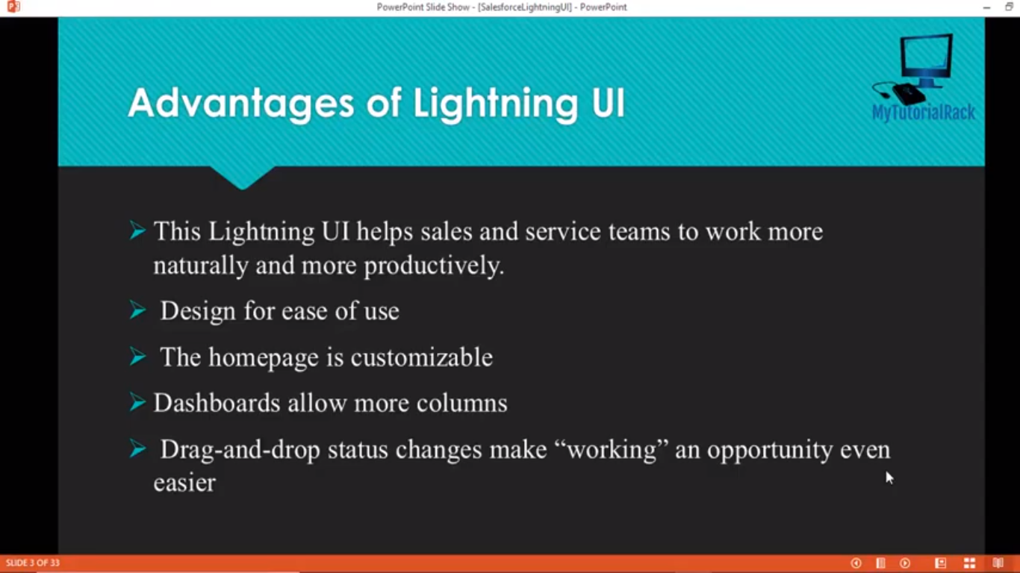

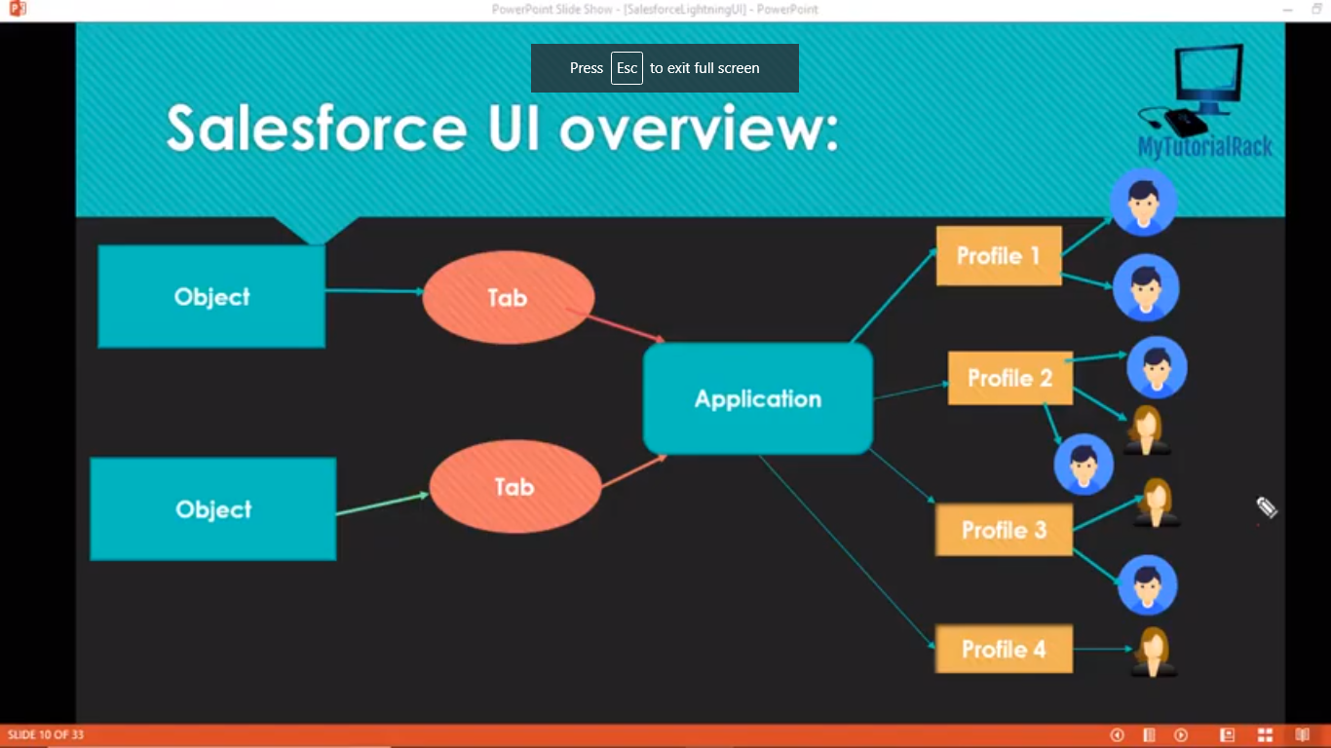

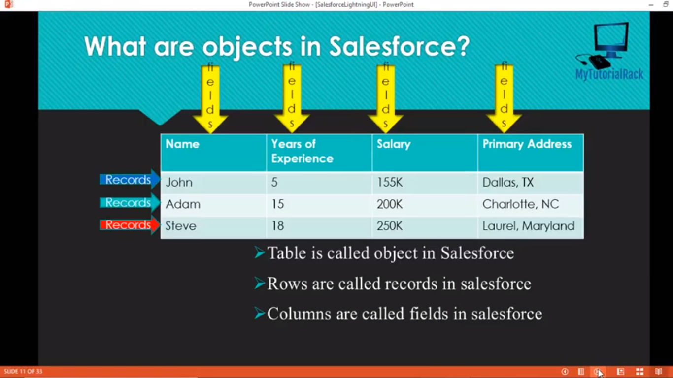

Objects that we create for any specific requirements are called as Custom Objects.

Objects that is already given to us by Salesforce are called Standard Objects.

Each of the Application is given to different kind of Profiles in Salesforce.

Profile controls the visibility of an Application (what Tabs, Applications, Objects we can see and access).

Every User will have a Profile in Salesforce and Each Profiles can be given to multiple Users.

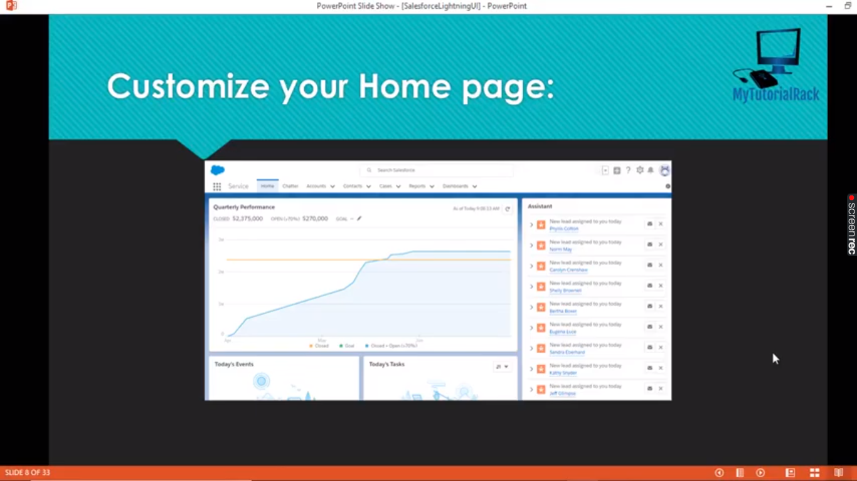

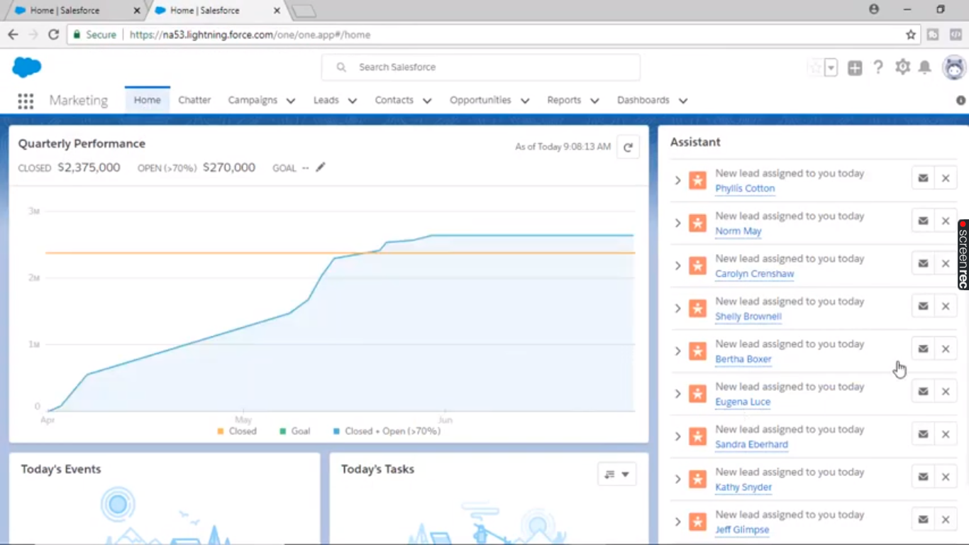

The Lightning App Builder provides an easy to use graphical interface for creating custom Lightning pages for Salesforce Lightning Experience and mobile app. Lightning pages are built using Lightning components—compact, configurable, and reusable elements that you can drag and drop into regions of the page in the Lightning App Builder.

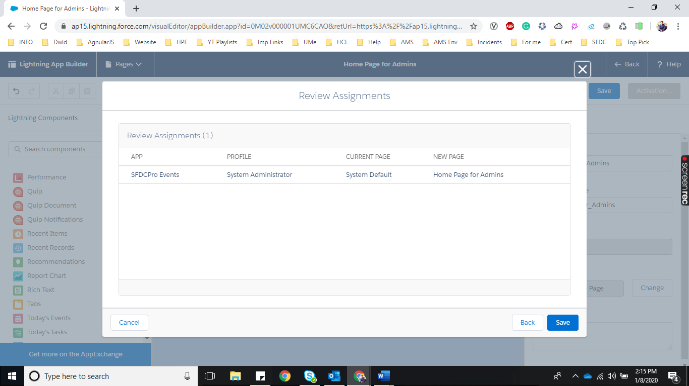

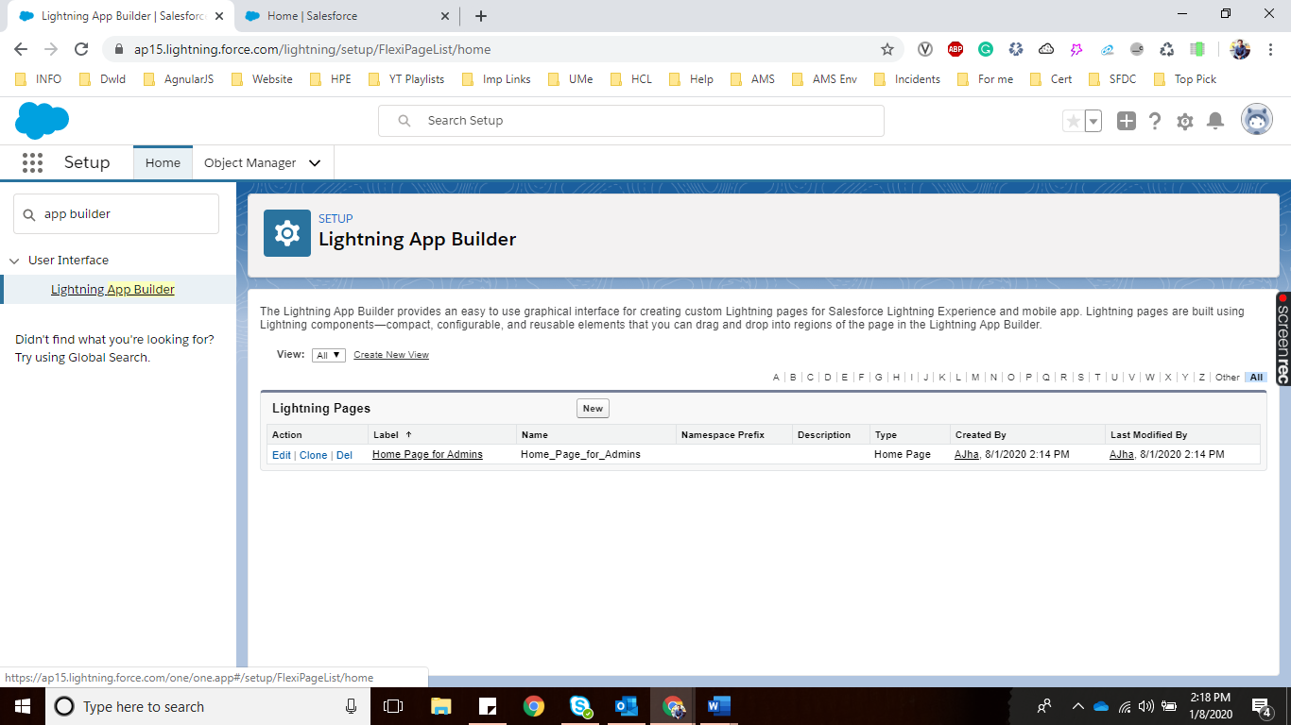

# **Kanban View:**

It gives a sales guy an easy way to change the Opportunity states.

This option can be found on Opportunity Object of Sales Application and View as Kanban.

